WMS Changes:

* 1. **Update FG Date – Exception**

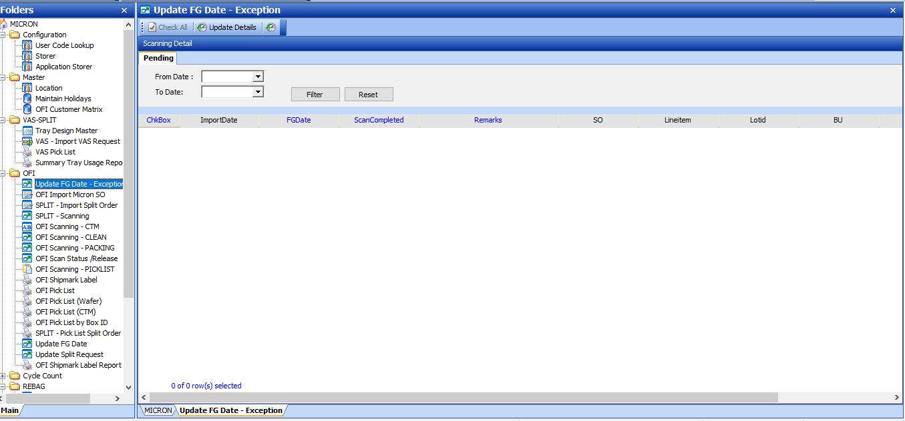

* + 1. **Input date:- Click [Filter] to retrieve FG Date – Exception request records**

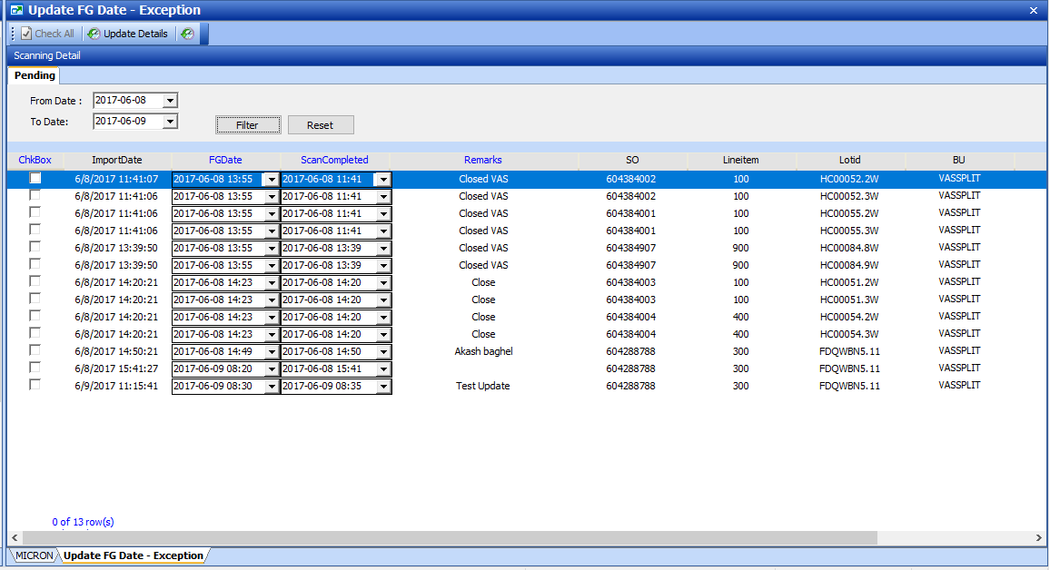

“Checked” on selected row:

* + 1. **Update FG Date, Input remarks**

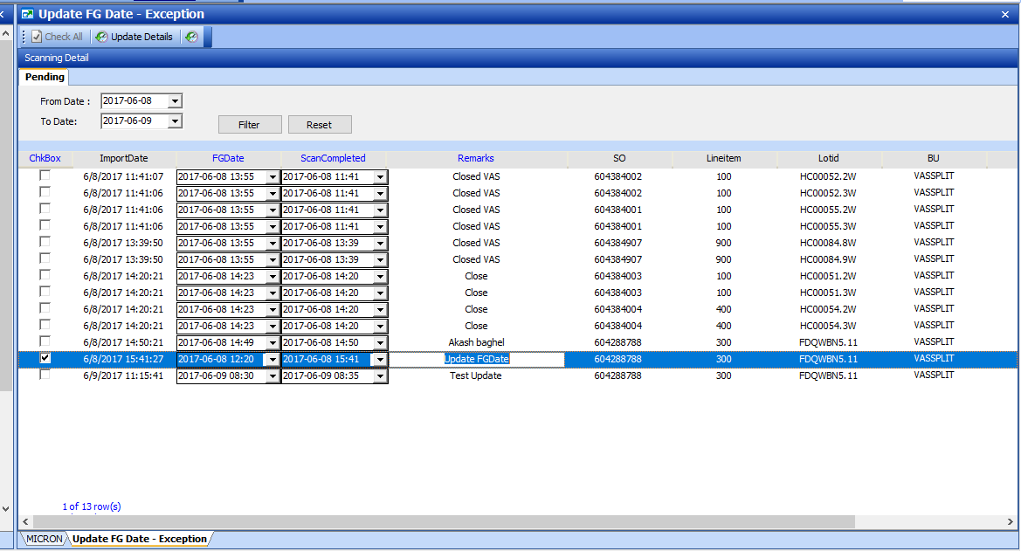

* 1. **Validation:**

1. FG Start date and completed date must not be future date

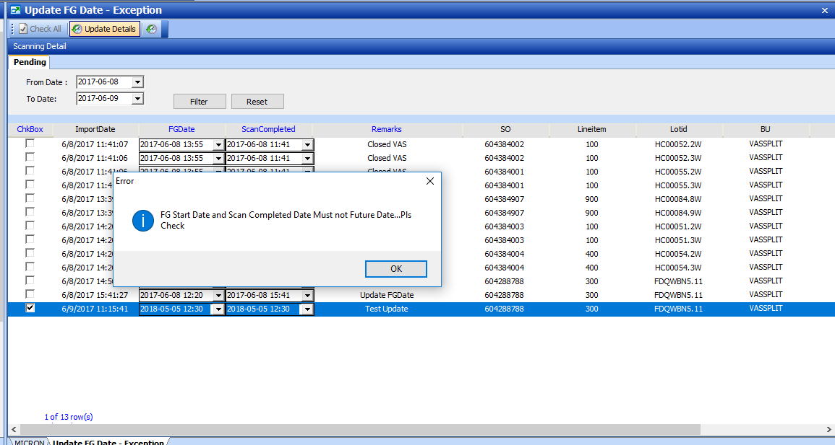

1. FG Date must be greater than scan completed date

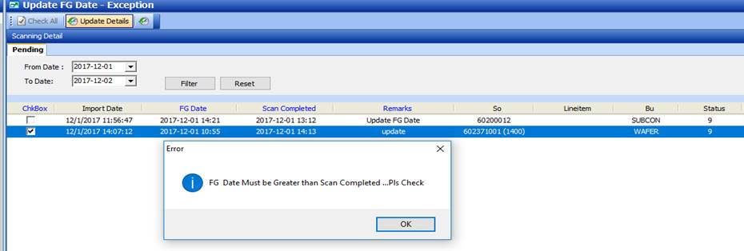

1. Remarks cannot empty

